Influence of Whole Body Vibration in balance and gait of patient with spastic cerebral palsy: A pilot study

Eun-Ja Kim¹,, Yong- Jin Jeon¹, Kyoung - Wook Choi²
¹ Dept. of Physical Therapy, Kyungdong University
²Dept. of Physical Therapy, Severance Rehabilitation Hospital

Abstract
Purpose: To study influence of Whole Body Vibration in balance and gait of patient with spastic cerebral palsy
Methods: The subjects for this study includes 20 ambulatory patients with spastic cerebral palsy of GMFCS level Ⅰ~Ⅱ. Whole Body Vibration training has been conducted in an inclined bed of 80 degrees with vibration frequency of 20Hz, 5 times a week, total of 6 weeks. Before and after the training, Pediatric Balance Scale ( PBS ) and 10-Meter Walking Test(10MWT) have been performed.
Result: After Whole Body Vibration, PBS and 10MWT examination showed significant result (p <0.05).
Conclusion: Significant improvement (p<0.05) in PBS and 10MWT after Whole Body Vibration is the proof that vibration affects balance and gait, and it is suitable for training to improve balance and gait of spastic cerebral palsy patients.

Key words: cerebral palsy, Whole Body Vibration, balance, gait, spastic

Ⅰ. Introduction
Cerebral palsy is a non-progressive lesion of the brain in infants or children that accompanies compound disorders in sense, cognition, speech, and behavior. Furthermore, vision and auditory impairment incurs secondary disorder in learning and cognition, and disorder of postural adjustment and motor function restricts physical activity ¹.
Children with cerebral palsy shows impaired postural adjustment and motor function due to vision, proprioception, and vestibular sensory integration disorder and abnormal muscular spasm ². Furthermore, impaired motor function due to changes in muscular tension induces secondary sensory integration disorder. Deficiency of postural adjustment, unsymmetric movement, limited range of motion, compensatory movement restricts opportunities of sensory experience in different environment and abnormal muscular spasm acquires imprecise proprioception feedback. Such outcome causes children with spastic cerebral palsy to develop inappropriate response to external stimulus than normal children ³.
Spasm and involuntary movement caused by abnormal suppression of cortical pathway by non-progressive cerebral lesion of cerebral palsy causes secondary deformation of musculoskeletal system, and muscular weakness causes delayed insufficient development, resulting in motor cooperation, balance, and gait disability ⁴. Excessive simultaneous contraction of agonist and antagonist and impaired anticipatory postural adjustment impedes faster recovery to stable posture when sudden postural sway occurs². and balance training in children with spastic cerebral palsy is very crucial for maintenance of stable posture in response to external stimulus, and balance training requires considerable time⁵.
90% of children with cerebral palsy exhibits gait disturbance⁶. and independent gait has great influence in quality of life⁷. Balancing while changing posture affects gait speed, step length, cadence⁸.
Whole Body Vibration is a training method that improves postural adjustment with proprioception stimulation in patients with impaired central nervous system and allows stable weight shifting in sitting or standing position while performing daily activities and better functional mobility⁹. In Whole Body Vibration, vibration stimulus stimulates Ia-afferent motoneuron in muscle spindles to activate α-motor neuron and increases motor unit firing rate, inducing strong muscular contraction by activating agonist and synergist¹⁰.
Whole Body Vibration improves postural adjustment in elderly, ultimately reducing risk of fall ¹¹, and mechanical stimulus onto muscle spindles by vibration increases muscular strength ¹². Whole Body Vibration in children with cerebral palsy strengthens weakened muscle and is suitable for muscle strengthening training that can replace muscular strength training that requires motivation of children. Therefore, Whole Body Vibration can improve balance and gait in children with cerebral palsy ¹³.
Several studies have conducted Whole Body Vibration in adult patient with impaired central nervous system, but few applies the training onto children with cerebral palsy. Current study is to learn influence of mechanical stimulation onto muscle spindle in balance and gait after implementing Whole Body Vibration on children with spastic cerebral palsy and provide a clinical evidence for Whole Body Vibration practice of children with spastic cerebral palsy

Ⅱ. Study method
1. Subject
Hospitalized children, medically diagnosed with cerebral palsy, in S hospital in Seoul have were selected for the subject, and 20 ambulatory children with GMFCS level Ⅰ~Ⅱ were finally chosen as subjects. Furthermore, children selected in the study were at least 6 months past recent surgery or Botox and guardian’s agreement was acquired.
Exclusion criteria are as following: those with uncontrolled seizure, those with visual, auditory, or perception impairment, and those with respiratory or orthopedic problem.

2. Whole Body Vibration method
Whole body vibration device (Galileo delta A Kipptisch, Novo tec, Germany) used in the study creates a cross-vibration that vibrates bilateral sides up and down, creates vibration of 5Hz~30Hz, and can be used in standing position at bed inclination of 0~90 degrees while bearing body weight.
The subjects received 3 minutes per set, 4 sets total while maintaining legs aligned at bed inclination of 80 degrees. 1 minute rest was given between the sets. Vibration was at 20Hz, and the training was conducted 5 times a week for 6 weeks.(Figure1.2)
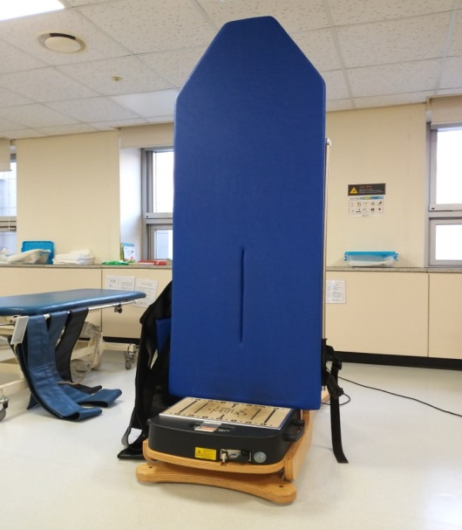
Figure 1.Whole body vibration
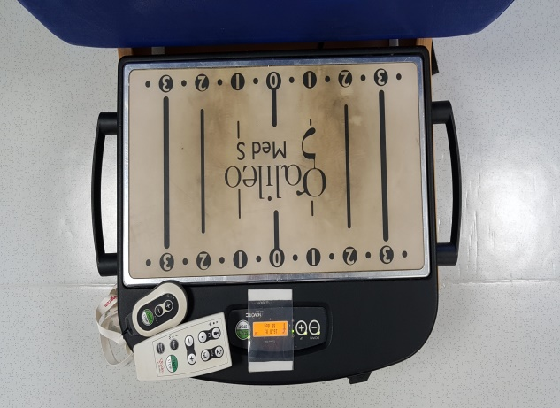
Figure 2. Whole body vibration

3. Measurement
1) Pediatric Balance Scale ( PBS )
Pediatric Balance Scale ( PBS ), which Franjoine et al. ¹⁴ has revised and supplemented BBS for children, has been used for evaluation of static and dynamic uprighting balance. PBS is a balance evaluation tool that has reduced static position time at 2,3,7 category for children with mild to moderate dyskinesia at age 5~15 to 30 seconds and revised and supplemented instructions to be simpler and clearer.
All 14 categories consists of 3 fields of sitting, standing, and postural change, and 4-scale score with minimum of 0 to maximum of 4 incorporates quantitative and qualitative aspect and provides diversity of evaluation. Total score is 56, and higher the score, the better uprighting balance is.

2)10-Meter Walking Test(10MWT)
10M walking test was conducted to measure gait capacity. Start and finish line were depicted with tape on the floor. Children were measured 3 times and the average of the 3 measurements was recorded. 10MWT showed high reliability of 0.81. ^{15.}

4. Statistic analysis
All statistic analysis of the study was conducted with SPSS ver. 18.0. General characteristic of the subject was portrayed of its result with descriptive statistics, and comparison between and after whole body vibration was conducted of paired T-test with significance level(α) of 0.05.

Ⅲ. Result
1. General characteristic of the subjects
20 subjects were selected for the study, with average age of 7.30±0.80, height, 36.35±31.76cm, and weight, 26.10±2.95kg. 14 were diplegic and 9 were hemiplegic. 9 were GMFCS level Ⅰand 11 were level Ⅱ (Table. 1).
Table 1. General characteristics of the subjects
 |  | subjects ( n=20 )
Age(years) |  | 7.30±0.80
Hight(cm) |  | 136.35±31.76
Weight(kg) |  | 26.10±2.95
Diagnosis | diplegia | 14
 | hemiplegia | 6
GMFCS | Ⅰ | 9
 | Ⅱ | 11

2. Comparison of PBS and 10MWT before and after whole body vibration
PBS in the subjects after whole body vibration was 46.00±7.85 before the training and increased to 49.20±6.76 after the training, showing statistical significance (p<.05), and 10MWT was 16.98±14.43 seconds before the training and decreased to 13.80±9.24 seconds after the training, which was statistically significant (p<.05)(Table. 2).
Table 2. The comparison of PBS ,10MWT within pre-test and post-test
subjects  ( n=20 ) | Pre | Post | t | Ρ
PBS(score) | 46.00±7.85 | 49.20±6.76 | -6.92 | .00
10MWT(sec) | 16.98±14.43 | 13.80±9.24 | 2.64 | .01
*p<.05.

Ⅳ. Discussion
Whole body vibration is a training program for safer and easier muscle strengthening for athletes that has been introduced from late 1990 ¹². In upright position on a vibration platform, vibration stimulus is transmitted from feet to other body parts and tonic vibration reflex in which mechanical stimulus of the vibration is transferred to the muscle causes muscle to contract. Reflex muscular contraction is caused by simultaneous activation of α and γ motor neurons by mechanical vibration, and mechanical stimulus by whole body vibration improves neuromuscular system to cause more voluntary muscular activation ¹⁶.
Whole body vibration as a new training program stimulates proprioception to increase agonist contraction as it increases motor unit fire rate and activates neuromuscular function. Furthermore, it is shown to have positive influence onto all systems, such as increased bone density, increased oxygen intake, increased blood flow, and decreased body fat, but scientific evidence of the positive influence by whole body vibration is insufficient. However, it is appropriate as a training program that can increase efficiency of workout with minimal effort in healthy individual or athlete ¹⁷.
Whole body vibration activates sensory region of brain and decreased heightened muscular tension in the patients with spasticity due to impaired central nervous system, and rapid vibration stimulates Ia-afferent motor neuron to secrete acetylcholine neurotransmitter for muscular contraction. Thus, constant vibration depletes neurotransmitter, reducing excitement of motor neuron and muscle contraction. Therefore whole body vibration can reduce spasticity caused by impairment of central nervous system¹⁸.
After performing whole body vibration onto patients with subacute stroke in knee-bent position on a vibration platform, the patients showed increased activity of lower limb muscle¹⁹. and strength of knee flexor was increased in chronic stroke patient with whole body vibration, showing identical outcome as active knee strengthening training and positive influence in BBS and TUG evaluation²⁰.
After conducting whole body vibration with children with cerebral palsy of GMFCS levelⅠ,Ⅱ, increase in their lower limb muscular thickness improved strength and helped improvement of gross motor function ²¹. Children with spastic cerebral palsy showed decreased spasticity after whole body vibration and positive results in TUG and 6MWT. Decreased spasticity of lower limb also allowed functional movement. Such outcome is due to muscular contraction caused by stimulated muscle spindles and α-motor neuron. It has advantage in that its effect is immediate after the training, but there is safety issue during the training¹³. Also, whole body vibration increases PBS score, shortens 10MWT time, and improves gross motor function, making it ideal for balance and gait training in children with spastic cerebral palsy²².
In this study which whole body vibration has been conducted in children with spastic cerebral palsy, showing increased PBS score and shorter 10MWT time which is consistent with the preceding study. It is considered to be due to vibration that strengthens weakened muscle and positive influence of spasticity reduction training in balance and gait of children with spastic cerebral palsy.
Children with spastic cerebral palsy has impaired posture adjustment and motor function as proprioceptive input is abnormal due to dyskinesia and developmental disability. Whole body vibration is appropriate as a training to improve balance and gait with proprioception feedback.
The study has its limitation in that its subjects are single-grouped and variables to the outcome from whole body vibration are limited.

Reference
1. Rosenbaum, P., Paneth, N., Leviton, A., et al. A report: the definition and classification of cerebral palsy April 2006. Dev Med Child Neurol Suppl. 2007:109(suppl 109):8-14.
2. Nashner, L. M., Shumway-Cook, A., Marin, O. Stance posture control in select groups of children with cerebral palsy: deficits in sensory organization and muscular coordination. Exper Brain Res.1983:49(3): 393-409.
3. Pavão, S. L., Rocha, N. A. C. F. (2017). Sensory processing disorders in children with cerebral palsy. Infant Beha Dev.2017:46:1-6.
4. Richards, C. L., Malouin, F. Cerebral palsy: definition, assessment and rehabilitation. In Handbook of clinical neurology (Vol. 111, pp. 183-195). Elsevier. 2013.
5. Shumway‐Cook, A., Hutchinson, S., Kartin, D., et al. Effect of balance training on recovery of stability in children with cerebral palsy. Dev Med Child Neur.2003:45(9):591-602.
6. Leonard, C. T., Hirschfeld, H., Forssberg, H. The development of independent walking in children with cerebral palsy. Dev Med Child Neur.1991:33(7):567-577.
7. Lepage, C., Noreau, L., Bernard, P. M. Association between characteristics of locomotion and accomplishment of life habits in children with cerebral palsy. Phys ther.1998:78(5):458-69.
8. Ko MS, Park SY, Lee NG. Correlation between pediatric balance scale and gait parameter in children with spastic diplegic cerebral palsy. J Rebah Welfare Engin & Assis Tech.2016:10(4):251-7
9. van Nes, I. J., Geurts, A. C., Hendricks, H. T., et al. Short-term effects of whole-body vibration on postural control in unilateral chronic stroke patients: preliminary evidence. Ame J phys Med Rehab. 2004:83(11):867-73.
10. Shinohara, M. Effects of prolonged vibration on motor unit activity and motor performance. Medicine and science in sports and exercise. 2005:37(12):2120-25.
11. Bruyere, O., Wuidart, M. A., Di Palma, E., et al. Controlled whole body vibration to decrease fall risk and improve health-related quality of life of nursing home residents. Arch Phys Med Rehab. 2005:86(2):303-7.
12. Bosco, C., Colli, R., Introini, E., et al. Adaptive respsonses of human skeletal muscle to vibration exposure. Clin Physiology.1999:19(2):183-7.
13. Cheng, H. Y. K., Ju, Y. Y., Chen, C. L., et al. Effects of whole body vibration on spasticity and lower extremity function in children with cerebral palsy. Human Mov Sci.2015:39: 65-72.
14. Franjoine, M. R., Gunther, J. S., Taylor, M. J. Pediatric balance scale: a modified version of the berg balance scale for the school-age child with mild to moderate motor impairment. Ped Phys Ther.2003:15(2), 114-28.
15. Lam, T., Noonan, V. K., Eng, J. J. A systematic review of functional ambulation outcome measures in spinal cord injury. Spinal cord. 2008:46(4):246-54.
16. Cardinale, M., Bosco, C. The use of vibration as an exercise intervention. Exercise Sport Sci Revi.2003:31(1):3-7.
17. Rhim YT. The study on whole body vibration as a new exercise-training prescription method. Kore Coach Dev Cent.2005:7(4):105-16.
18. Ahn MC, Song CH. Immediate effects of local vibration on ankle plantarflexion spasticity and clonus of both the gastrocnemius and soleus in patients with spinal cord injury. J Kore Soc Phys Med.2016:11(2):1-11.
19. Kim JH. The Effects of whole body vibration exercise on balance and lower extremity muscle activity in stroke patients. J Kore Soc Phys Ther. 2013:25(5):266-72.
20. In TS, Song CH. The effects of whole body vibration on knee extensor strength, and balance and walking ability with chronic stroke. J Kore Soc Phys Med.2010:5(4):675-83.
21. Lee WB, Lee HS, Park SW et al. Effects of whole body vibration training on lower limb muscle thickness and gross motor function in children with spastic cerebral palsy. J Kore Soc Phys Med.2019:14(4):195-201.
22. Jung, Y., Chung, E. J., Chun, H. L., et al. Effects of whole-body vibration combined with action observation on gross motor function, balance, and gait in children with spastic cerebral palsy: a preliminary study. J Exer Rehab.2020:16(3):249-57.

